Name: Sean Carlo D. Baldovino
Course: BSIT
Section: 4E
Date: 12/08/2026

# Objectives
Installing Virutal machine box and install both ubunto and windows 11 enterprise in the virtual machine box
# Software Installed
Git, Github desktop, virtualmachinebox, ubuntu, windows 11 enterprise
# Professional Accounts
GitHub:
LinkedIn: https://www.linkedin.com/in/sean-carlo-baldovino-000559369/
# Installation Screenshots

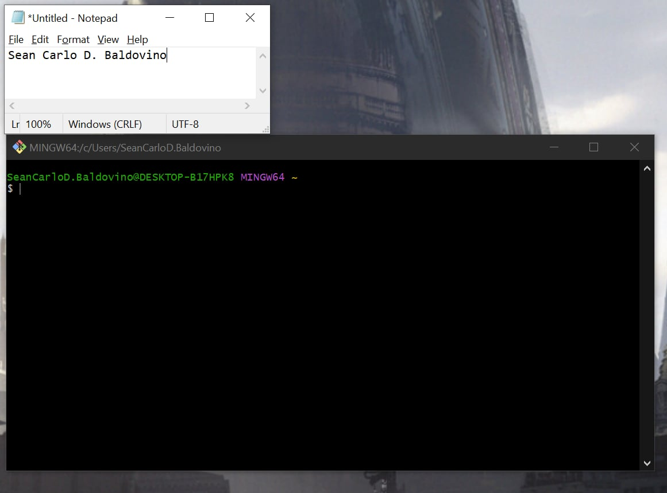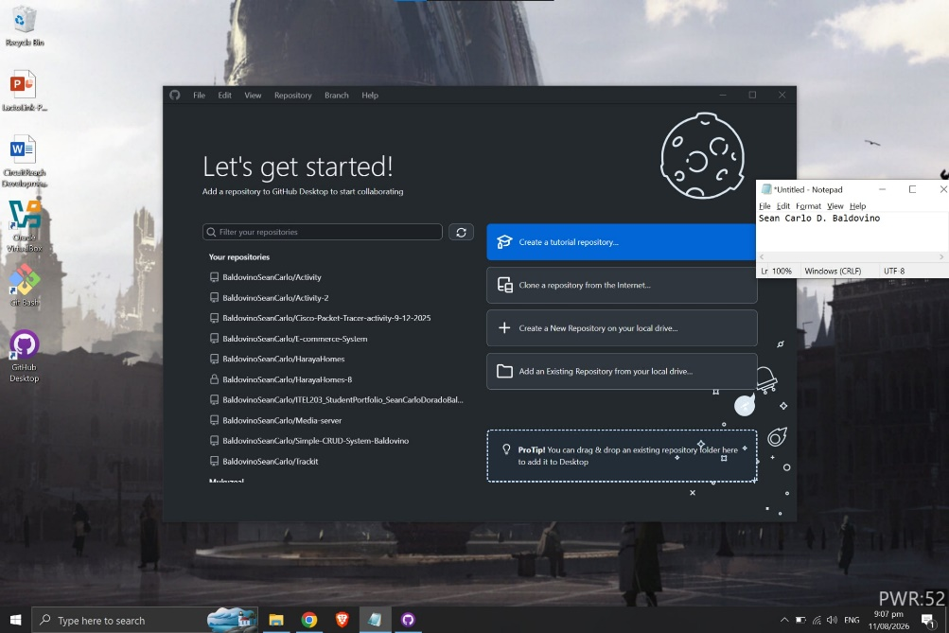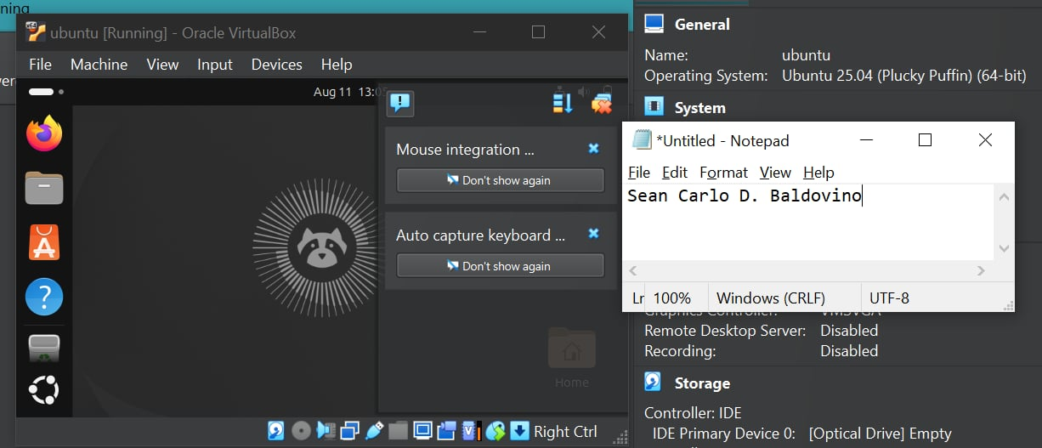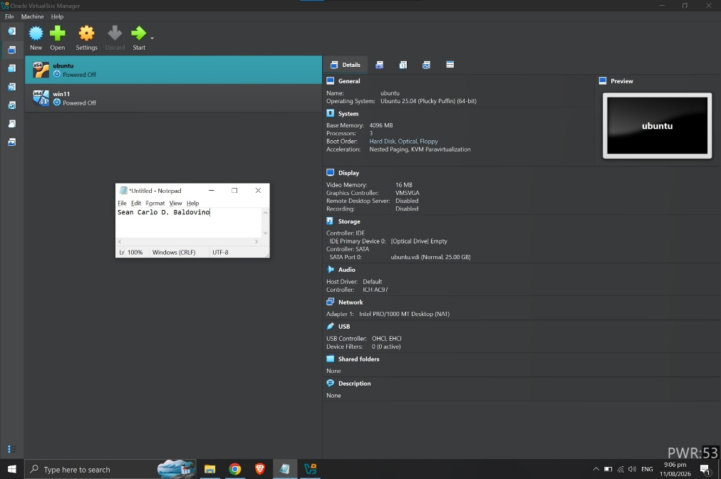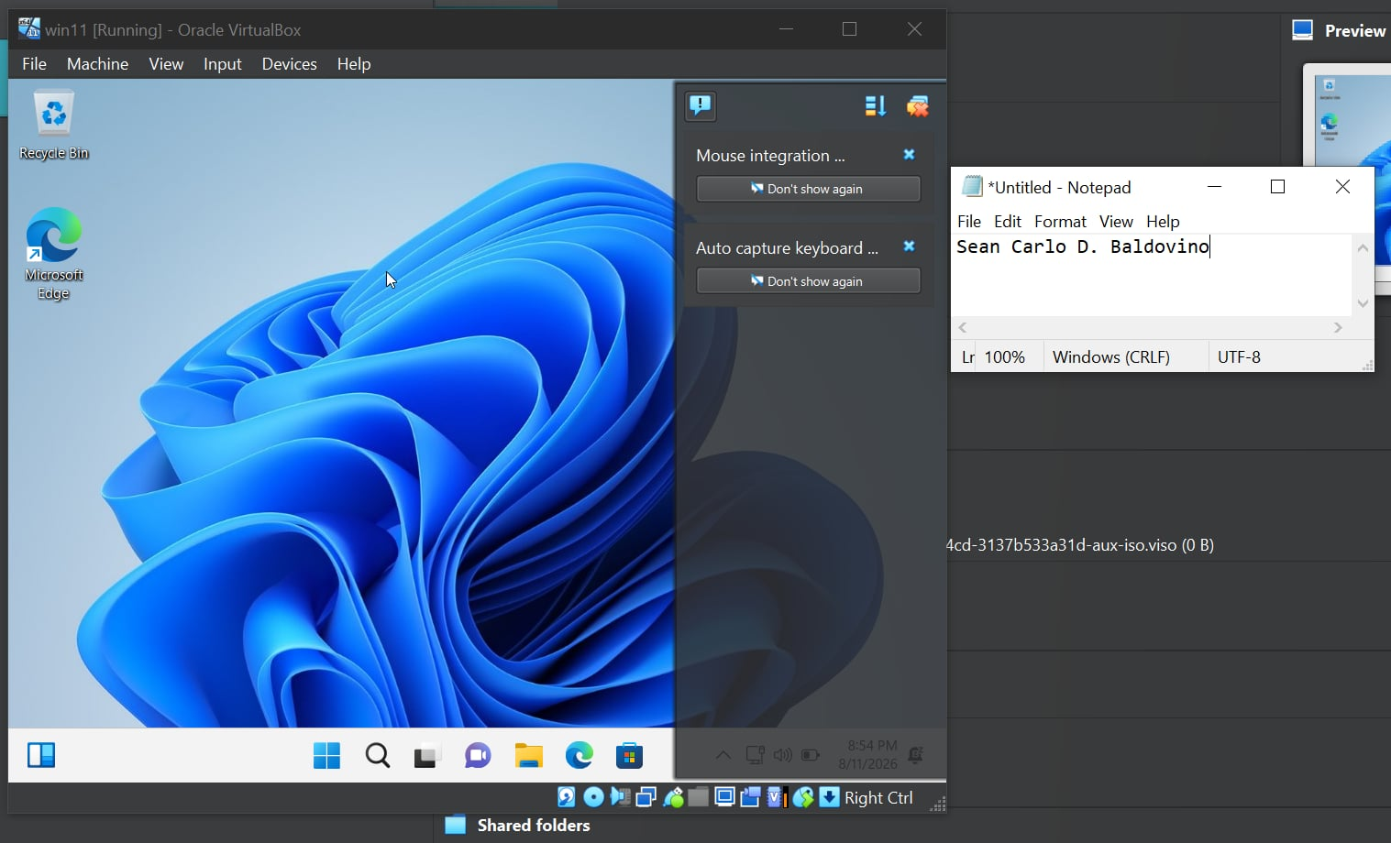
# Challenges Encountered
Distributing ram and cpu in the virtual machine box because my laptop is only limited to 4 cores and 4gb of ram so it took a while to finished and sometimes crashed or hanged during installation of ubunto iso and win 11 iso
#Reflection
I learned a lot about System Administration and Maintenance. It is really important to have an organized environment for System Administration activities. A System Administrator needs to have skills but also needs to be good at documentation organization, version control and always be learning.

I got to know some tools that will be really helpful like Git for version control GitHub Desktop for managing repositories Visual Studio Code for writing and editing code and documentation and VirtualBox for virtualization. I also learned about using Ubuntu as a Linux operating system and setting up a Windows evaluation environment. These tools will help me practice System Administration tasks and keep track of my progress.

I also made accounts on GitHub and LinkedIn. GitHub will let me build a portfolio with my laboratory activities, documentation, scripts, configurations and projects. LinkedIn will help me share what I am learning and make a digital presence.

My goal for this course is to get better at System Administration, Linux, virtualization, version control and technical documentation. I want to be more confident when it comes to troubleshooting and managing computer systems. Overall Week 1 was really helpful. Gave me a good foundation for my future laboratory activities. It also taught me why it is important to have a portfolio as an IT student. System Administration is what I am focusing on. I am excited to learn more, about System Administration.

